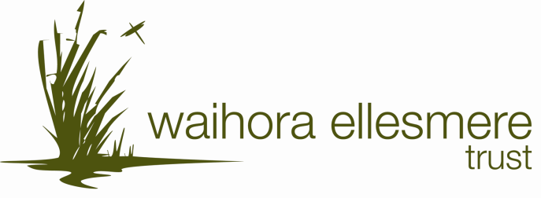

Membership Form

By becoming a member of the Trust you will be part of a team, helping us to make a positive contribution to Te Waihora/Lake Ellesmere and its catchment. You will

- Receive newsletters (also available on the website)
- Have speaking and voting rights at our AGM or special meetings
- Be able to be on WET committees and get involved in projects
- Be eligible for election to the Trust Board
- Have opportunities to access information and resources
- Be able to take part in events, workshops and seminars, some of which may be limited to members

Annual Subscriptions

WET’s membership year is from July 1 to June 30

Individual Adult: $25
Junior (under 16yrs): $5
Family: $30
Organisation: $50

We can accept payments by cheque or cash or you are welcome to pay using internet banking.
Bank Details
For Direct Credits our bank account number is 02-0860-0003375-000.

Donations

In addition to becoming a member we welcome donations and, as we are a Charitable Trust, a tax rebate can be claimed on donations of over $5. Donations will contribute to projects the Trust is involved with.

WET Membership - please complete and return to the WET office

Subscription type – please circle Adult Junior Family Organisation

Name: __________________________________________

Address: __________________________________________

__________________________________________

Phone: __________________________________________

Email: ___________________________________________

Please note, our newsletters and upcoming events information will be sent out by email wherever possible to save paper and to make the best use of our resources. The file size will be small and suitable for a dial up connection. If you do not have access to an email address we will post newsletters.

Subscription amount: $____________

Donation amount: $___________

Method of payment – cheque / cash / direct credit (please circle one – please do not post cash)

Family membership
If you are joining as a family, please indicate how many adults and how many children are in your family.

Organisation
If you are joining as an organisation, please tell us how many member your organisation has.

Skills
Do you have any skills you would like to offer WET? (eg specialist knowledge of plants/animals/local history, photography, practical restoration skills etc).

Your suggestions
We welcome suggestions for new projects or ways we might implement the Community Strategy. Please tell us your ideas!

